Define discourse:  linguistics a unit of language, especially spoken language, that is longer than the sentence. The term is used by linguists when investigating features of language that extend beyond sentences.  Define: Vygotskian  The concept of “tools of the mind” comes from the work of Russian psychologist Lev Vygotsky. He believed that just as physical tools extend our physical abilities, mental tools extend our mental abilities, enabling us to solve problems and create solutions in the modern world. When applied to children, this means that to successfully function in school and beyond, children need to learn more than a set of facts and skills. They need to master a set of mental tools—tools of the mind.  http://www.toolsofthemind.org/philosophy/vygotskian-approach/ | Predications for chapter  A discussion of how discussion in class can aid in the understanding of literature.  1923- The New Democracy in the Teaching of English Walter Barnes stated that “English classes [were] ineffective… because [it] failed to motivate students or prepare them for lives of reading of using English in any way but hi8ght literary ways. (p. 321)  Quickly for the story and not studiously for the literary craft.  Questions that were present at the time of Barnes book—  - What is the role for oral discourse in the classroom?  - What oral discourse skills should student be taught or given a chance to practice, as part of their instruction?  - How should we define “reading” in English class—as reading for enjoyment, reading to learn how authors think, or reading for discussion of the text?  - What should we emphasize in teaching writing—real-life forms like letters or school-based forms like literary analysis essays?  Furthermore:  - Should student be expected to read challenging science or history texts? or can they learnt hose subject matters better by hearing about them from teachers who understand them?  - Should students be expected to focus on reading original sources in the disciplines they study or do simplified synthetic presentation of the material suffice  - Should students be trained to give oral presentations about their learning or to participate in debates and discussions of content-matter related topics  - What is the role of talk in the learning and the reading we expect of students?  This chapter reviews the literature regarding these issues and in particular the literacy outcomes of using oral discourse in the classroom.  Learning of content matter, vocabulary, and or oral discourse skills themselves  Oral discourse is a foundation for reading and understanding in all things related to the written word.  Questioning the author—QtA  Learning to use ‘tools’ is crucial to further growth for young children.  Oral discourse is one of those tools.
What is the NCES birth cohort study?  National Center for Education Statistics:  The Early Childhood Longitudinal Study, Birth Cohort (ECLS-B) was designed to provide policy makers, researchers, child care providers, teachers, and parents with detailed information about children's early life experiences. Data collected for the ECLS-B focus on children's health, development, care, and education during the formative years from birth through kindergarten entry.  http://nces.ed.gov/ecls/birth.asp  What is IRE sequences?  Initiation response evaluation | HISTORIAL BACKGROUND  References to previous beliefs and research, but one study states that oral discourse is “essential to move from modeling to application” (p. 322)  The authors intend to share more current research that speaks to the merits of oral discourse in the classroom as a way to deepen the understanding of reading materials.  Current trends and Issues  Definition of Oral Discourse  Is oral discourse a skill or a context for learning?  This chapter limits oral discourse as “extended oral productions, whether monologic or multi-party, centered around a topic, activity or goal.”  Oral discourse to literacy comes in 2 forms:  - correlational and prospective research showing that children with high oral discourse skills tend to learn literacy skills with ease  - instructional or intervention studies that inject support for oral discourse into the classroom  Oral discourse during emergent and early reading  Talking about stories for the very young increases their level of comprehension and also heighten vocabulary development.  Dialogic Reading and Text talk, using textual support as evidence of understanding, are marketed to increase vocabulary but they also seem to raise comprehension through deep analysis of stories.  Oral Discourse as Related to Conventional Reading  Initiation- Response- Evaluation Sequence:  - establish a purpose for reading  - activating relevant background knowledge  - posting open-ended questions that require deep processing  - responding to student initiatives  - promoting peer interaction  KEEP model- importance of “instructional conversation”  “New knowledge is built through participation in topic-focused talk in which students and teachers have equal participation rights, teachers play the role of guide or facilitator rather than the expert, shared background knowledge is taken as a starting place, and open-ended questions are frequent.” (p. 325) *
*this sounds a lot like Destination Imagination. But also close reading that I use in my classes. Specifically, in reading a simple text like Hill Like White Elephants students come to understand—through guided questions—just what a story is about.
Why was it not technically possible?  What is meant by Type I Error?  rejection of the null hypothesis in statistical testing when it is true  What is reciprocal teaching?  Reciprocal teaching refers to an instructional activity in which students become the teacher in small group reading sessions. Teachers model, then help students learn to guide group discussions using four strategies: summarizing, question generating, clarifying, and predicting. Once students have learned the strategies, they take turns assuming the role of teacher in leading a dialogue about what has been read.  http://www.readingrockets.org/strategies/reciprocal_teaching/ | Collaborative Reasoning  Participation in discussions produces deeper thinking. Useful in both reading and writing.  Oral Discourse During Middles and Secondary Grades  Correlational Studies  Long tradition of research looking for correlations between teaching practices in a classroom and reading outcomes.  “Not technically possible” to describe how classroom instruction predicted student reading growth.  Studies by Gamoran and Nystrand (1991) observed a significant lack of actual discussion in English and social studies classes.  Paideia Seminars: format where students and teachers read complex text in advance of class and come to class prepared to discuss.  Experimental and Quasi-Experimental Studies  RECIPROPCAL TEACHING  Students who participated in this type of situation—showed dramatic improvements in overall reading comprehension.  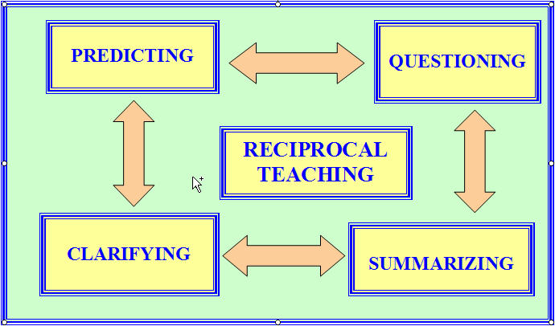
**Why didn’t third graders show stronger results?  What is different about this population?  Define: talk moves*  http://www.educatoral.com/wordpress/2013/10/16/talk-moves/  Interesting that this post is just a few days old. | Reciprocal teaching has been tested in all grade level and has demonstrated both positive and neutral results.  An exception to this appears to be in third grade situations. (p. 328)**  QUESTIONING THE AUTHOR (QtA)  Teachers lead discussion where students question the author.  The theory/ method assumes that authors can be wrong.  It looks at authors bringing their own biases and perspectives to their writing.  “Talk moves” Significant increases in discussion noted in classroom observations.  Students were able to provide more evidence “in their own words” in support of their interpretations of a text.  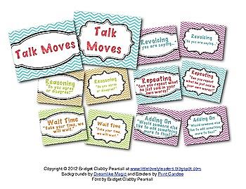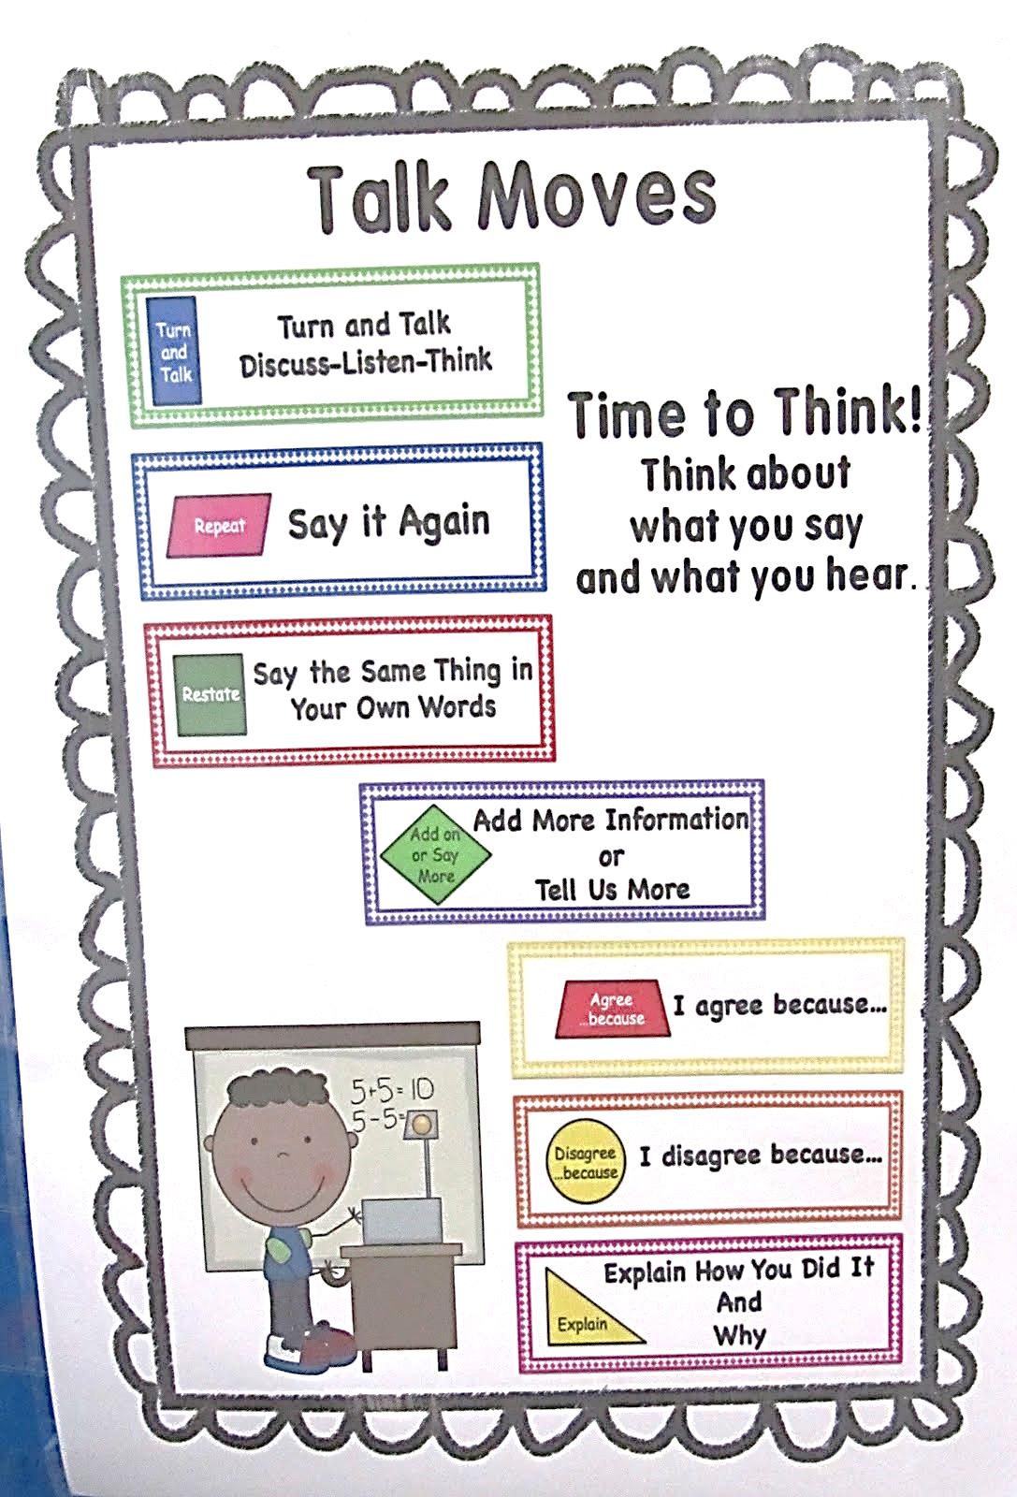  ACCOUNTABLE TALK (p. 329)  - evidence of participation  - linking ideas- both students and teachers  - asking and providing knowledge  - asking for and modeling rigorous thinking  authors say that more needs to be done to show teachers how to use these method effectively.
Define: Reading apprenticeship see next page  http://www.readingapprenticeship.org/cs/ra/print/docs/ra/approach.htm | WORD GENERATION (WG)  Goal to help student develop vocabulary of higher rating academic words across a variety of disciplines through frequent and increased exposure.  Units are shared weekly.  Introduced within a text about a controversial theme. Ending with a debate. Take a stand essay.  Authors state that improvements demonstrated in studies showed gains for students not necessarily because of their newly acquired definitions and meaning of vocabulary, but rather from an increase in literacy achievement determined by their participation in active class discussions.  Components of Discourse-Rich Programs  Teacher Talk  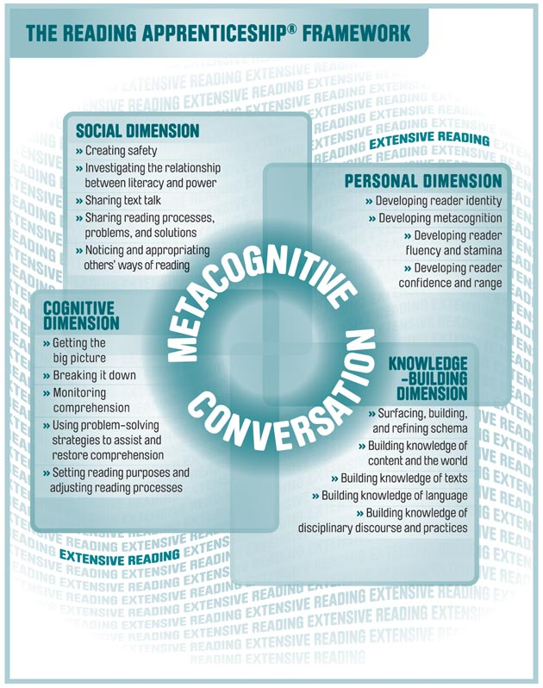  Discourse in schools depends heavily on students’ prior knowledge. In some situations, this is culturally determined. Good teachers must take this into account.  Reading Apprenticeship Framework—  Teachers do the following:  - Modeling- show how you read difficult text  - Direct explanation- show how to attack text  - Marking- turn it back to student  - Verifying & clarifying student understanding- revoicing students’ comments  Parameters of Discussion Protocols  Highlights of programs—  - Interpretative authority  - Control over turns (order, air time)  - Control over topic  - Open-ended and genuine questions  Implications for Practice, Policy and Future Research  Practice—  - Start with worthy questions [Who determines “worthy”]  - Students and teacher share both authority & participation rights  - Time for peer interaction is available  - Explicit goal for the discussion has been established  - Rules about appropriate contributions to the discussion are known to all participants  More training for teachers in how to use these strategies is needed.  While the importance of class discussions is clear, it seems that still—in most situations—little time is actually spent in this activity.  Further research  Which features of “book clubs” support student learning  Provide guidelines for the use of discussions in classes at different ages and levels  Microgenetic research—look at groups and how they progress  Which is better? Peer peer or teacher peer?  Look at implementation—how can teachers best lead, launch and facilitate discussions?  How can teachers evaluate student learning and quality of student contributions?  What features are important? Face-to-face? Written? Online? Is it social engagement?  Secondary students should demonstrate competence in discourse skills- debate, oral argument, discussion.

Our Approach
When secondary and college students don't read with understanding, or avoid reading academic texts altogether, what can help?
Reading Apprenticeship draws on teachers' untapped expertise as discipline–based readers and on students' untapped strengths as learners.
The result is a research–based, research–tested partnership that benefits students and teachers alike.
Randomized controlled studies have shown that with Reading Apprenticeship,
- Teachers increase the effectiveness of their disciplinary teaching.
- Students build both reading and subject area competence.
- Students gain the dispositions to engage, problem solve, and persevere when faced with challenging academic texts.

Reading Apprenticeship Framework
Reading Apprenticeship instructional routines and approaches are based on a framework that describes classroom life in terms of four interacting dimensions that support reading development:
- Social: The social dimension draws on students' interests in peer interaction as well as larger social, political, economic, and cultural issues. Reading Apprenticeship creates a safe environment for students to share their confusion and difficulties with texts, and to recognize their diverse perspectives and knowledge.
- Personal: This dimension draws on strategic skills used by students in out–of–school settings, their interest in exploring new aspects of their own identities and self–awareness as readers, their purposes for reading, and their goals for reading improvement.
- Cognitive: The cognitive dimension develops readers' mental processes, including their repertoire of specific comprehension and problem–solving strategies. The work of generating cognitive strategies that support reading comprehension is carried out through shared classroom inquiry.
- Knowledge–Building: This dimension includes identifying and expanding the knowledge readers bring to a text and further developing it through personal and social interaction with that text. Students build knowledge about language and word construction, genre and text structure, and the discourse practices specific to a discipline — in addition to the concepts and content embedded in the text.
These dimensions are woven into subject area teaching through "metacognitive conversations" — conversations about the thinking processes students and teachers engage in as they read. "Extensive reading" — increased opportunities for students to practice reading in more skillful ways — is the necessary context for this framework to succeed.

From http://www.educatoral.com/wordpress/2013/10/16/talk-moves/

Three Main Parts of a Productive Classroom Discussion:
Generating Ideas:
- Elicit/share ideas as many as possible.
- Give students a sense of ownership of the discussion.
Comparing and Evaluating Ideas:
- Students encouraged to talk about ideas mentioned.
- Teacher begins to think more about content of the discussion but open-ended discourse still encouraged.
Focusing the Range of Ideas:
- Teacher narrows focus by asking students to look at one particular idea.
- Teacher actively concerned about content issues and takes more control of discussion.

Whole Class Talk

Guidelines for Whole-Class Talk:
Explain: “This is my solution/strategy…” “I think _____ is saying that _____.”
- Explain your thinking and show your thinking.
- Rephrase what another student said.
Agree with Reason: “I agree because…”
- Agree with another student and describe your reason for agreeing.
- Agree with another student and provide an alternate explanation.
Disagree with Reason: “I disagree because…”
- Disagree with another student and explain or show how your thinking/solution(s) differs.
Build On: “I would like to build on that idea…”
- Build on the thinking of another student through explanation, example, or demonstration.
Go Beyond: “This makes me think about…” “Another way to think about this is…”
- Extend the ideas of other students by generalizing or linking the idea to another concept.

The Five Practices
Clarify the Content Goals!
- Predicting – What ideas do you think students will have?
- Monitoring – What ideas are emerging? (While they work.)
- Selecting – Which student ideas to use with whole class?
- Sequencing – In what order to use students’ ideas?
- Connecting – What talk moves or other questions can help students compare and connect important ideas?

Discourse Moves (Talk Moves)
- Probing – questions or prompts to get students to make public more of their thinking.
- Re-Voicing – teacher repeats or paraphrases what a student has said in order to achieve instructional goal.
- Pressing – teacher does not allow students to offer shortcut responses, unsupported claims.
- Putting an Idea “on hold” – when topics are entered into the discussion that are off-topic, or are better addressed later on, teachers politely put on hold the introduced idea.
- Using Wait Time – teacher allows adequate wait time following a question (10 sec) depending on type of question.
- Asking Students to Respond to Someone Else’s Reasoning – teacher asks to restate or apply their reasoning to someone else’s.

Talk Formats (Lower Risk)
Individual (lowest risk)
- Clarify my own ideas before hearing others.- Articulate my ideas in written words, drawings.
- Teacher monitors written ideas in the room; may clarify the task and encourage students.
Pairs (low risk)
- Try out my ideas with one other person.
- Practice articulating my ideas in spoken words.
- Hear another’s ideas in relation to mine.
- Teacher monitors written or spoken ideas; may encourage participation or probe students’ thinking; may ask permission to share the pair’s ideas with whole class.

Talk Formats (Higher Risk)
Small Group (medium risk)
- Share and hear ideas from several people.
- Do something with the ideas – sort, organize, compare, prepare for whole-class sharing, etc.
- Equity – are all useful ideas being shared?
- Teacher monitors written and spoken ideas; may probe students’ thinking; may encourage or ask permission for group to share with whole class.
Whole Class (high risk)
- Spread ideas to all students in the room.
- Pair or groups present ideas to whole class.
- Teacher uses talk moves to orchestrate discourse; visual tools help represent and work with various ideas.

